Portfolio: Purchase Ledger

Contents Page:

- Overview of project
5. Project Setup
7. Recording Stage
9. Logic and Bug Fixing stage
19. Live Deployment
21. Conclusion

Overview of Project:
I joined the Robotics Process Automation team (RPA) and was assigned to the Purchase Ledger work with another apprentice. The RPA team focus on automating processes to reduce the burden of repetitive, simple tasks for employees and businesses. Below their criteria for automating tasks can be seen:
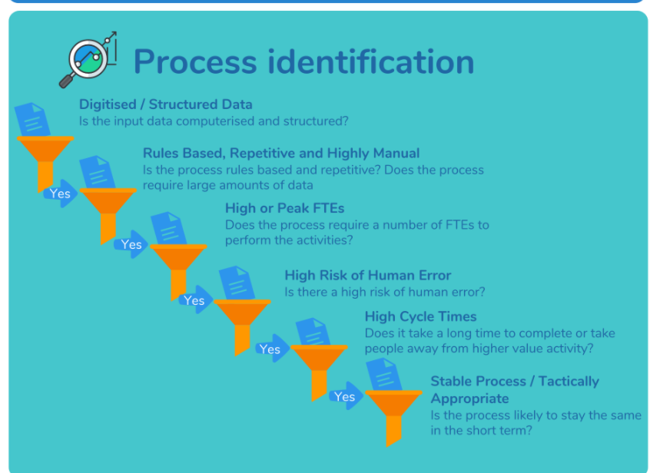

The Purchase Ledger (PL) ticket I was assigned to previously required an employee to manually check each invoice on great plains versus the purchase ledger and ensure the invoice totals match, if they do match the employee posts them. My ticket involved taking this process and automating it using a software called Kyron. The first phase of this process was completing the ‘happy path’, i.e when the invoices match they are posted. Below is a sample of the jira ticket (fig 1).
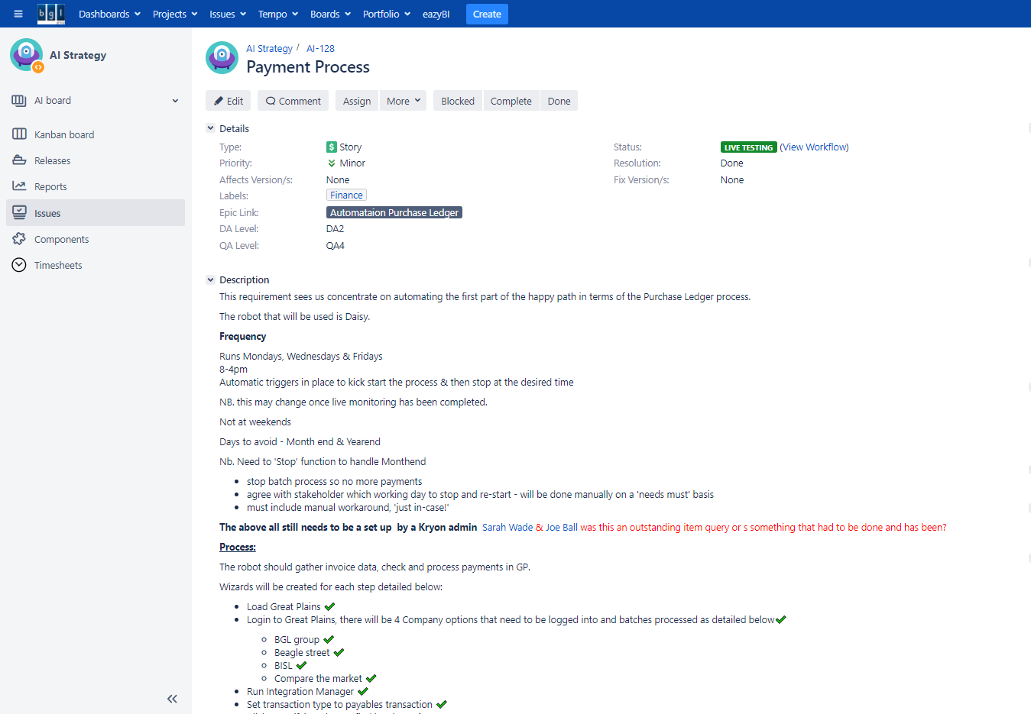
Fig 1. Jira ticket for PL:

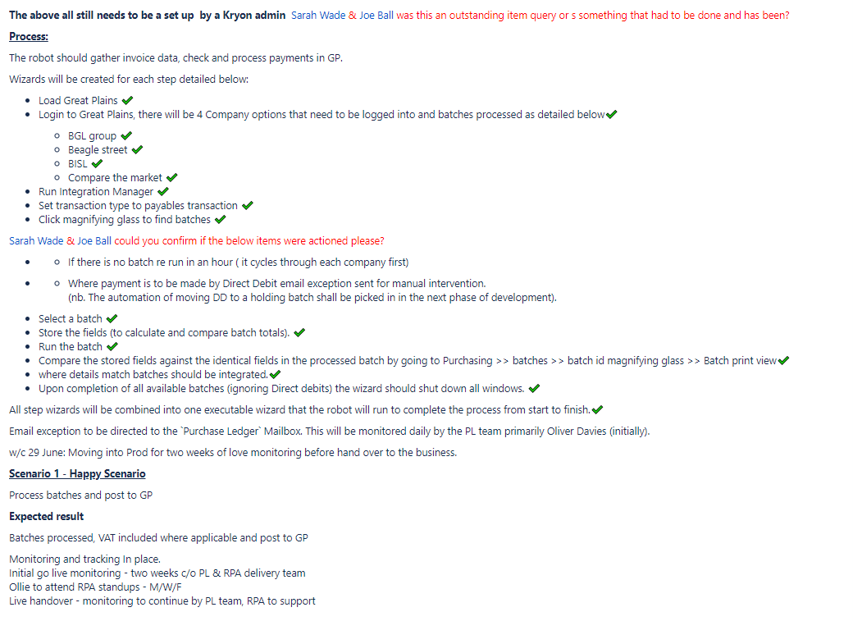
Current Purchase Ledger Process:
Assistants go into Great plains and select a batch, they use a separate excel sheet to gather the invoices and manually compare the totals for each batch and ensure they are correct. They add on any needed VAT and sort direct debits into a ‘DD holding batch’ to be processed. Once the invoice total is confirmed to match the purchase ledger, the batch is posted.

Brief overview of software used:
Kryon is an innovative software that records a user’s exact actions and allows them to be automated. Firstly you ‘record’ a step in your process then edit it within Kryon studio. Kryon studio allows the user to apply logic, flow and variables to the recorded process. The process when completed is then run on a virtual machine by a robot. The robot used for this purchase ledger process was labelled ‘Daisy’.
The process involved in a “Kryon Recording” in a nutshell:
Record user manually completing the process. Store as "Wizard" in studio.

Upload each separate wizard to Kryon and optimize detected objects

playback recording from Kryon to ensure correct behavior

Add advanced commands in Studio and add any logic (e.g. if page empty move to next wizard)

If process shows no errors and behaves as expected deploy to robot to run automatically on a virtual machine.

I created the above diagram to explain the recording process.
Microsoft Great plains: is an accounting software used by my company’s finance department.

People Involved RPA Team:  Joe: Junior Software Engineer working on Purchase Ledger (pair programming)  Ed: Product Technician, technical coach  Abi: Senior Software Engineer,  Amanda: Senior Business Analyst for Purchase Ledger  John: Senior Business Analyst, RPA.  Paul: Senior Business Manager, RPA | People Involved Elsewhere:  Duncan: Purchase Ledger Assistant, Product-owner  Cindy: Purchase Ledger Manager, Product-owner  Ollie: Purchase Ledger Assistant, Citizen Developer  Andy: Great Plains Admin  Adam: SME

Project Setup
This project had previously been initiated then shelved, so there was already a list of requirements and decisions made.
My first step was to create a spike in Jira to establish the previous design outline and what requirement had been previously stated. This was created with support of John (business analyst) and Joe (apprentice developer). John talked us through the conventions used in the RPA team, which I then applied when creating this spike.

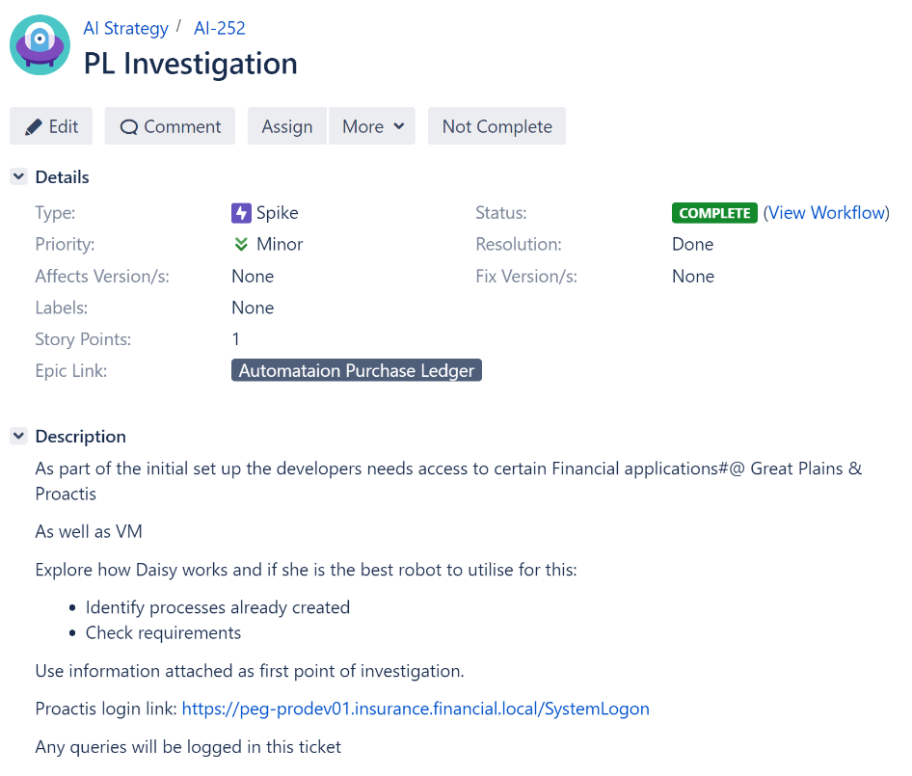
Fig 1. Jira Ticket for PL:
To get a further view on the current situation I met with up Joe and Adam (the SME for the previous purchase ledger work). Adam answered the list of questions I had on the process and had some suggestions as to how best to proceed.

Next Amanda (BA), Joe and myself met with the Stakeholders and asked for confirmation of the requirements and a walkthrough of the process. I recorded this for future reference. Duncan (our main product-owner) gave me a list of requirements that he would like the process to achieve, which I added to the ticket.

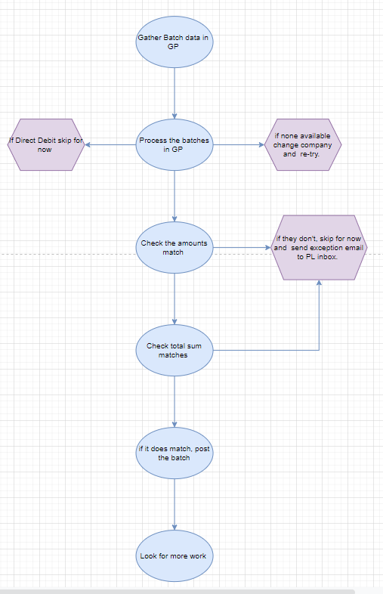
After talking to both the SME and Stakeholder I created a high-level flow diagram to outline the required process (fig 2).
Fig 2. Process Flow PL:

Joe, John and myself met up to do an inception. As a team, we broke the process down into stages to be pointed; and identified areas we needed a clearer picture on. I questioned whether we needed to use an excel sheet to complete the data comparison. I contacted Adam(SME) again with these questions.
I created a structured plan of the program that in accordance to development standards in the RPA team; used a separate wizard (i.e program) for each main step of the process. For example, a wizard with the sole responsibility of logging the robot on, and a wizard with the sole responsibility of holding and storing required variables.

With the knowledge from Adam I decided not to use an excel sheet to compare the batch totals in the PL process and instead do a direct SQL query using Kryon. Kryon can save the two batches separately as variables and compare them using a maths operator, which is a lot more efficient than getting the robot to load another program and using excels maths operators to do the calculations. This would save process time and reduce the capacity for error.

Overall the progress during this phase was at times a little slow, in retrospect it would have been more beneficial to include Adam in the initial outline meeting. This would have saved time on making some of the decisions.

Initially after speaking with the product owner, I was going to go ahead with using the current purchase ledger team’s way of working; which involved using the excel sheet. Talking to the SME was incredibly valuable and resulted in a decision being made to go straight to SQL instead. This is a more ideal result in terms of meeting the business needs.

Recording Stage

This stage of the development covered recording the basic steps of the process and configuring Kryon to be able to complete it autonomously.
I decided to begin working in order of the current process. This involved using Kryon to screen record a user logging into great plains and logging into a company. Kryon’s configuration required developers to configure each mouse click and use ‘object detection’ to tell it where to go. I recorded a user posting a matching batch with no errors and manually checking the totals. This was loaded in Kryon as a ‘Wizard’ and saved for editing. I broke down the stages of the process into different wizards which can be edited later in order to incorporate flow and logic.

Some of the login screens were very similar meaning Kryon had a difficult time locating its detection object sometimes. I spent some time altering the settings and using Kryon documentation to find a solution to this problem. I found a solution in the Kryon documentation. This was to use a window object, which can help Kryon identify which page it is on. See figure 3.
Fig 3 Detecting unique objects in Kryon:

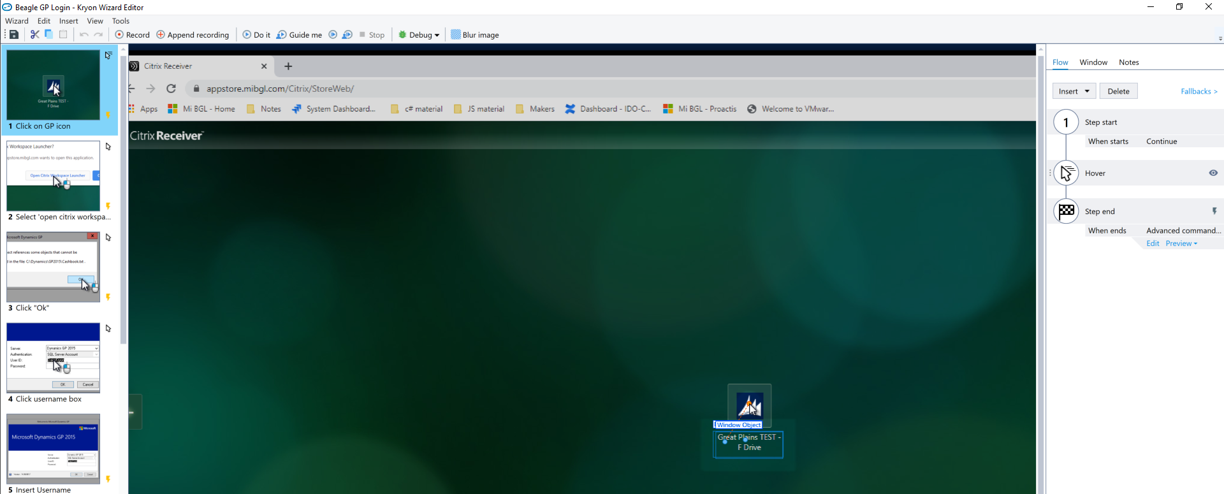

The next part of the process was to program Kryon to open the integration assistant within great plains. The integration assistant is the internal marco which enables user to look at invoices. Upon attempting to record this, it was discovered that on the test server the integration assistant was out of date and un-useable. I immediately contacted Andy, the admin for great plains and asked him to update the server so I could proceed.

Once this was updated I recorded the required step and configured each part in Kryon. Next, I pair programmed with Joe and troubleshooted the parts that didn’t quite have the correct behaviour.
Kryon was having trouble reading the batch ID and saving it to a variable so I worked closely with Joe to try and trouble shoot this using Kryon documentation. When together we had failed to find a solution I contacted Ed, my technical coach for Kryon for assistance. Ed also struggled to find a viable solution that did not add substantial length to the process.

This is where I decided to contact Ollie, the citizen developer in group finance. As the citizen developer, he would be taking over the purchase ledger management when the process was complete and is very familiar with the current PL process. He suggested an alternative function in which we could use the pdf printer to ‘grab’ the batch ID; for the second ID the excel sheet would be the only way to grab the second batch total.
This decision meant the excel sheet use would be required again. I informed the product owner in a catch-up meeting that there would be extra steps as the excel sheet was now required.

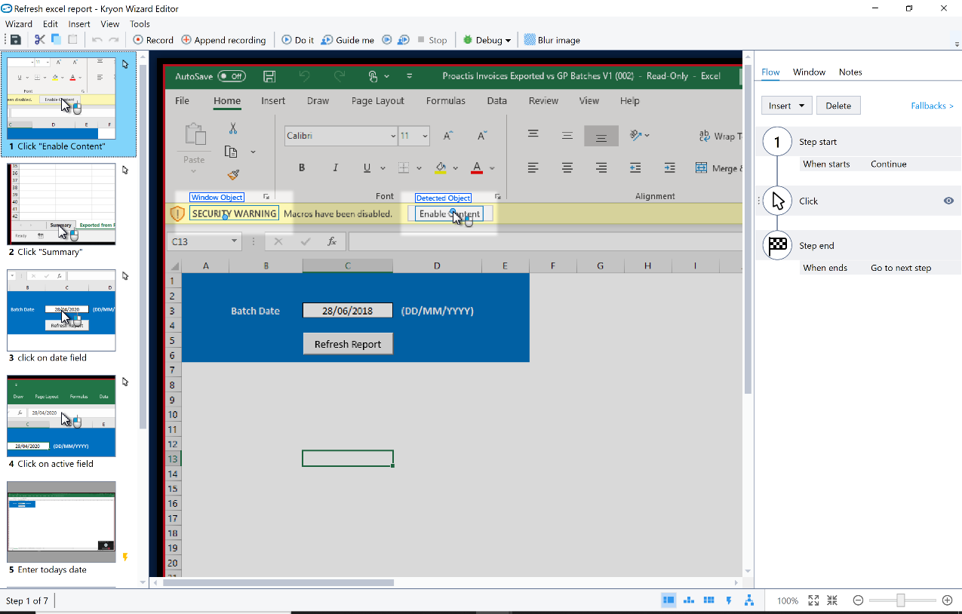
The addition of the excel sheet meant I had to request access to it through the finance department, which took a few days to come through – adding time to the entire process. Displayed below (fig 4) is a screen shot of the excel wizard to highlight the additional number of steps that was now required.
Fig 4. Excel sheet wizard:
I decided to still use Kryon’s maths operators to do the batch comparison instead of the excels own one, keeping all the variables within the master wizard where they are easy to find. This is part of the RPA teams best practice approach and would help with de-bugging in the future. At the end of this stage I followed the RPA team approach to source control and made a separate copy of the wizard as a backup and saved it in a separate place. As this wizard would be accessing financial programs, according to my company’s security protocols I needed to ensure that no passwords were exposed in the program. I facilitated the use of the Kryon ‘vault’. The vault is only accessibly by senior RPA admin and enables usernames/ passwords to be stored in a secure manor as a variable that can be referenced within a wizard in a way that only shows that a password was used and not the details.
The result of this recording stage was a complete basic wizard that could replicate the actions of the original user’s input. At this stage, there was no logic added. Unfortunately, the fact we had to extend the master wizard to include the excel steps mean it is considerably longer, this isn’t ideal for the business case which requires the process to be simple and repetitive. It will add time to each cycle of completion, but the robot will still be able to meet the needs of the purchase ledger team. I communicated this to the product owner, who was completely happy with this resolution, as the excel spreadsheet was part of their current process anyway.

Adding Logic and Bug Fixes Stage

This part of the process development built upon the basic wizard. The main flow and logic to support its deployment needed to be added, along with fall-backs.
- Adding the different program logic was the first step, I pair programmed with Joe for this stage taking turns to be the navigator/ driver. I broke the process into the four main criteria of the ticket so that I could easily evidence that each requirement had been met. The four stages were:
- Reading and comparing batch ids, and acting accordingly:
  - I needed to program the wizard to be able to correctly take the read batch ID’s and totals and complete behaviour based upon when it reads. This includes posting the batch if it matches, but if it didn’t match an exception needed to be raised and the robot should skip over that batch next time it looks for work.
- Logon switching:
  - The four main tasks involved firstly ensuring the robot would switch to a different work environment after completing all tasks in one.
- Fall-backs:
  - Secondly fall-backs should be added through-out the wizard to ensure when the robot cannot complete its task, or finds an error that this is handled correctly.
- Ignoring direct debits (and emails a purchase ledger assistant to alert):
  - The robot also needed to be programmed to ignore any direct debits it may come across, as it was not in the scope of the current ticket. It was essential that a direct debit was not accidentally processed at this stage.
The entire process also needed thoroughly manually testing, and a test plan needed to be created in order to gain QA sign off (via a meeting with a quality engineer). As the process is tested all errors or potential errors would be handled as they occurred.

Lastly throughout this part of development I held several sessions with Ollie, the purchase ledger team’s ‘citizen developer’. As I completed parts of the logic I kept Ollie involved ready for the project handover at the live monitoring stage. I also added detail to the jira ticket so that it was clear for Ollie, when he picked it up, exactly what the process was covering at the moment.

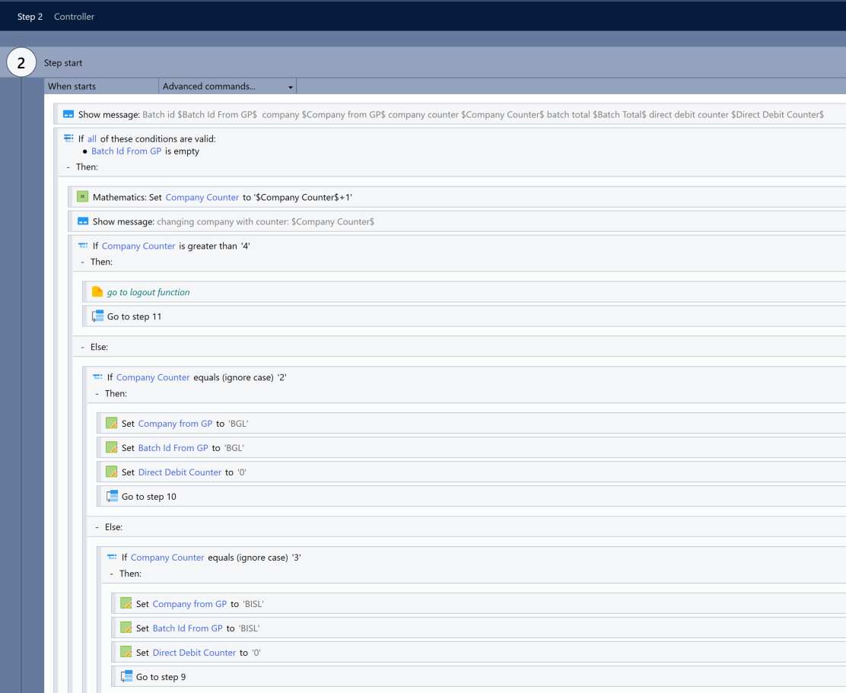
I started by adding the logic required to do the main purpose of the wizard, which was to look at the gathered batch id’s and totals, and compare them. If the totals match the batch would process as usual however I needed to handle what happened when they don’t match. As we were pair programming, Joe programmed the wizard to compare the initial amounts, and I added in the fall-back to handle when the batched didn’t match. For my ticket, this meant the wizard sent an email exception with all the details of the batch to a designated member of the purchase ledger team. In addition, it needed to remember to skip over this batch as it continued to look for batches. I implemented a for loop to handle this logic. I implemented display messages for testing purposes (fig 5 below). The messages displayed the expected collected variable information so I could visually ensure it’s behaving as expected.
Fig 5. Adding messages for de-bugging and testing logic

I manually tested each part of the process in the same manor and responded whenever the wizard did not behave as expected. One bug encountered was the robot sometimes failed to log in on the main logon screen. I diagnosed what was going wrong by running Kryon in DeBug mode, which displays exactly what the wizards is doing. The error was due to GP being very slow to load, and sometimes Kryon would try to move onto the next page before it loaded. In addition, the next page of the logon had the same screen heading so Kryon sometimes didn’t notice it had failed to load, this threw out the process occasionally.

Running it in Debug mode highlighted this problem (see fig 6) .
Fig 6. Window confusion
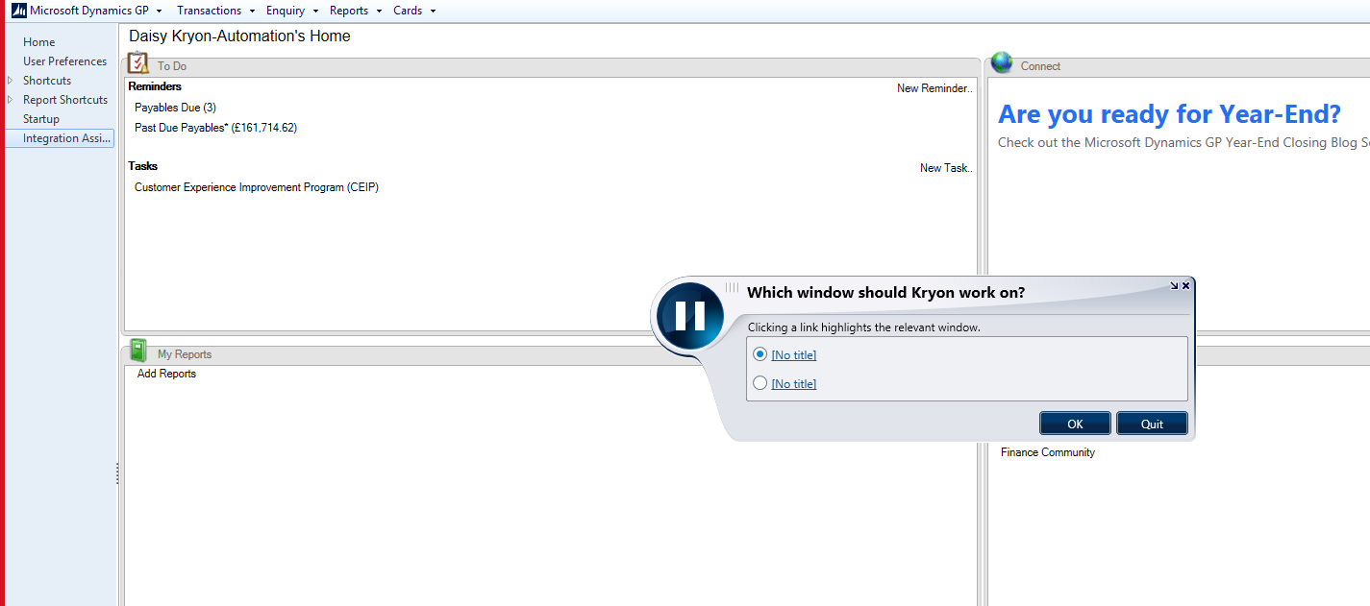

I problem solved this error by increasing the window wait time and adding some fall-back logic to the specific logon wizard. (See fig 7).
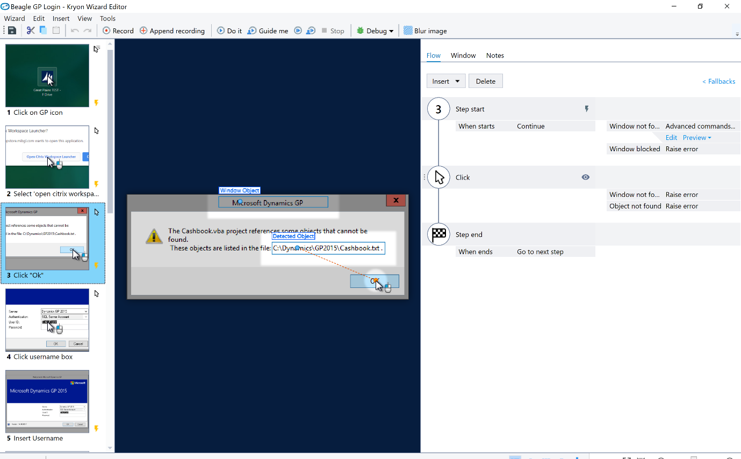
Fig 7. If window not found, advance commands.

Fig 8. Fall-back advanced commands
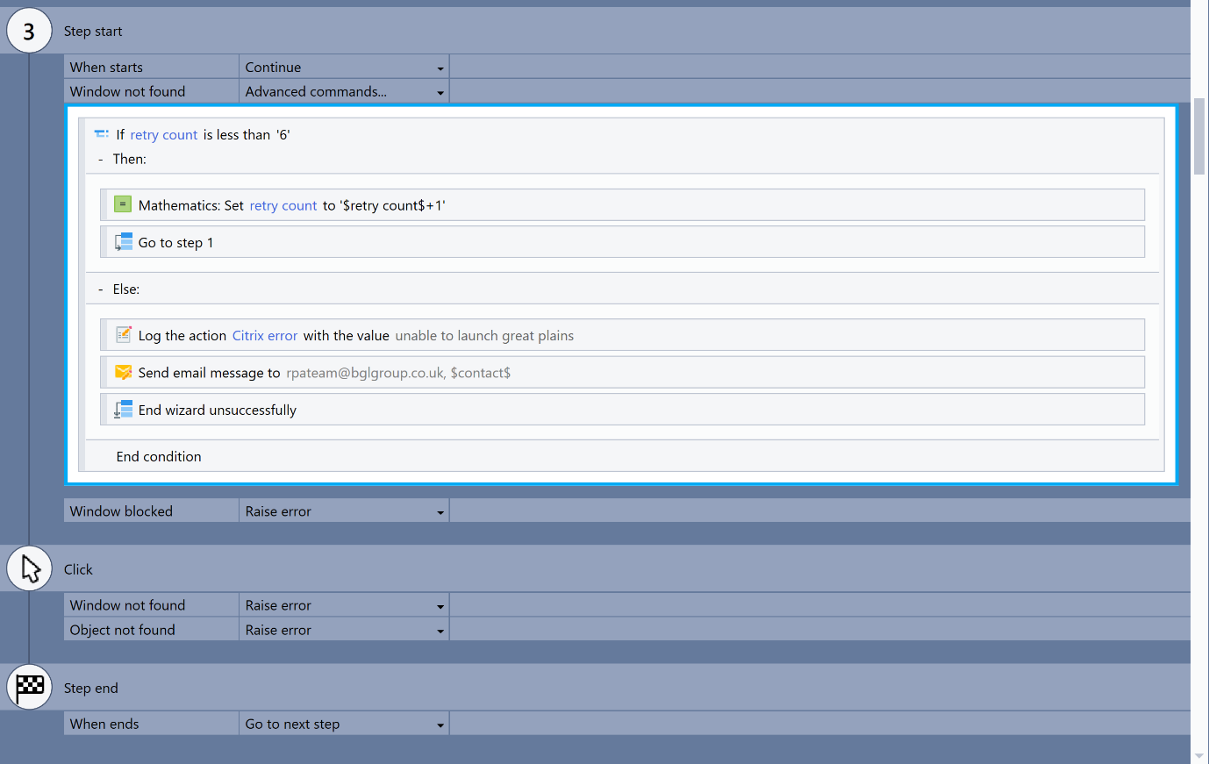

As you can see from the above images (fig 7 & 8), I programmed Kryon to respond to the window not being found by going into advance commands. I added an if statement to re-try finding its detected object. If the robot could not find its object 6 times, an error would be raised. I programmed the error to firstly be logged in Kryon and to secondly send an exception email. Afterwards the wizard would cleanly shut down to prevent errors.
I then further manually tested the process using the debug trace to see exactly what was going on (fig 9).
Fig 9. DeBug trace output

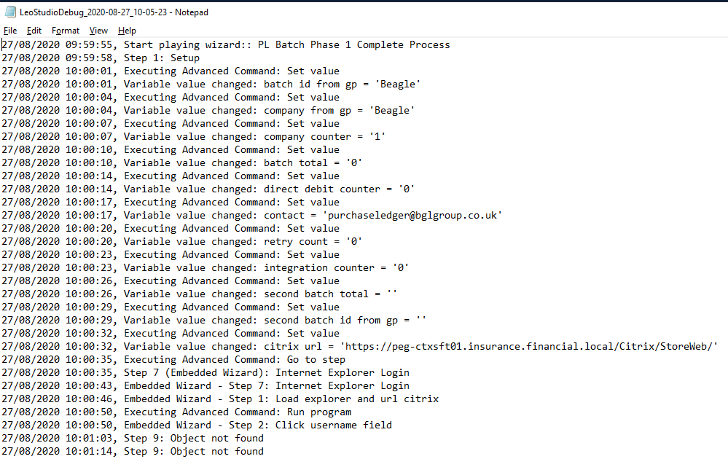

The long loading times were still triggering ‘object not found’ errors, which triggered the fall-back causing the program to shut down (object not found in the fig. 9). I responded by increasing the window-wait time to 30 seconds (fig 10).
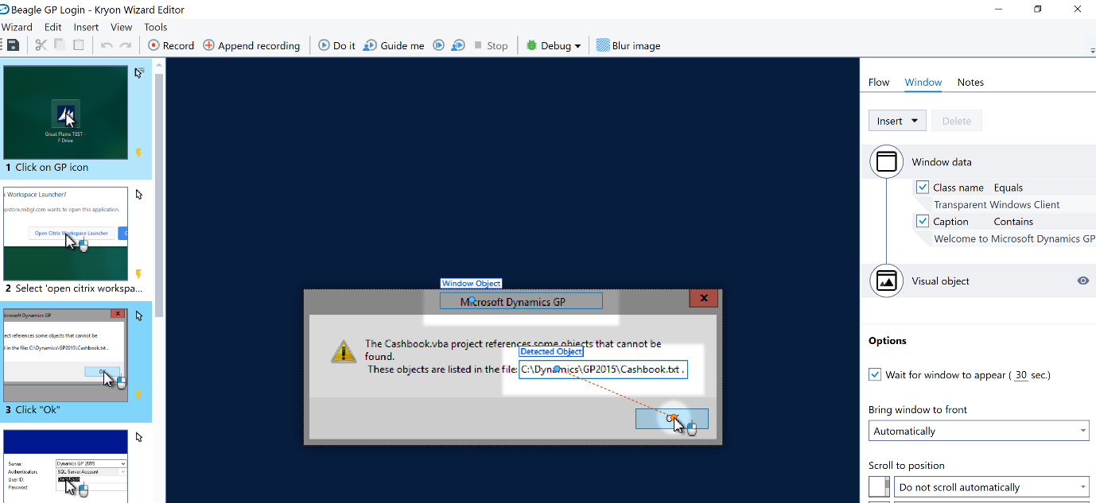
Fig 10. Window Wait
Fig 9. Adding window wait

After further manual testing this appeared to fix the issue and allowed the wizard to continue.
I held an update meeting with the product owners and BA’s where a live demo was planned for our next session. At this point I was still not comfortable with the performance/ reliability of the process. I had a meeting with our BA Amanda to discuss whether to go ahead with the demo. I voiced concerns over it not performing perfectly and that a live demo would risk showing it not working correctly, causing less confidence in the program. Amanda agreed it would be better for our product owners to have good confidence in our process, in which case pushing back the demo was the logical result.

Due to the delay of the demo one of the senior managers of the RPA team, Paul asked to be kept informed with progress. With this in mind, I created a confluence page with a list of all currently known bugs. I updated with page with resolutions and errors are they were encountered and updated (fig 11 below). I also kept in contact with Paul over teams daily (fig 12 below).
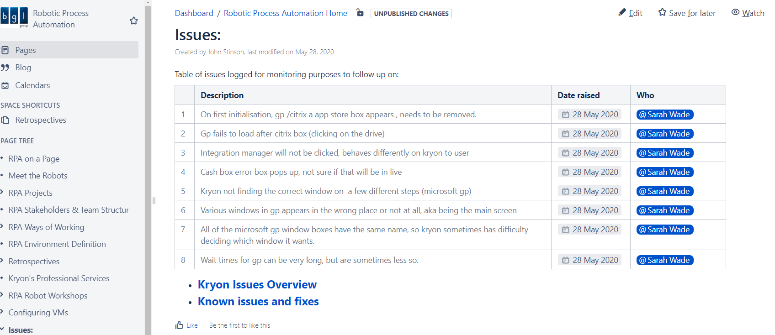
Fig 11. Confluence page of errors.

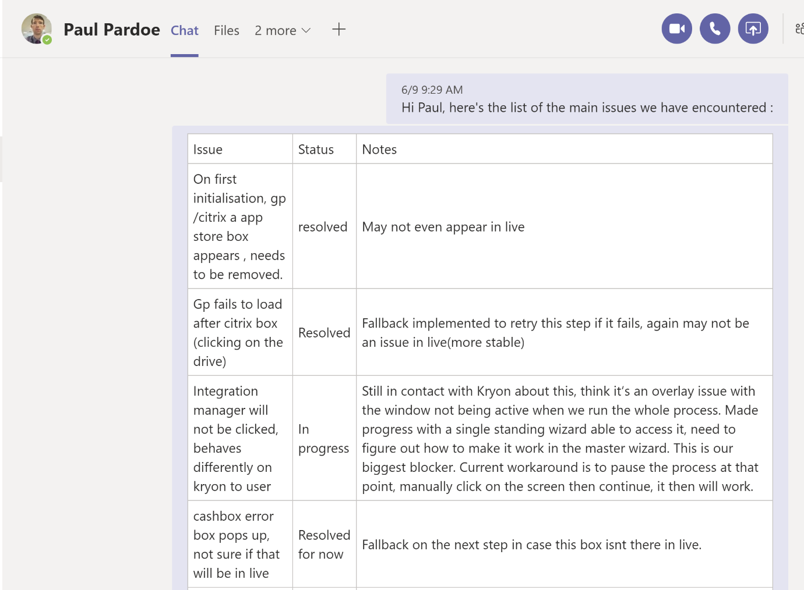
Fig 12. Sample of information sent to Paul, including status.

During testing I noticed one error kept appearing. When loading great plains, the robot often struggled to open the integration manager. This step required the robot to click upon an icon within great plains.
I sectioned off the part of the wizard experiencing this error and repeatedly re-ran the wizard in debug mode to attempt to identify what was causing the error and how I could fix it. I discovered integration assistant required the browser to be active before it loaded. Usually this would happen when a user clicked on the browser, but for some reason when replicated with Kryon this would not trigger it.

I added attentional clicks to the wizard to attempt to fix this. The idea was the first click would ‘activate’ the window, allowing Kryon to access the integration assistant (fig13 & 14). I also added a pause, to give the browser time to load properly, Great Plains is built with frames so each section loads separately.

Fig 13. The integration manager & Added advance commands
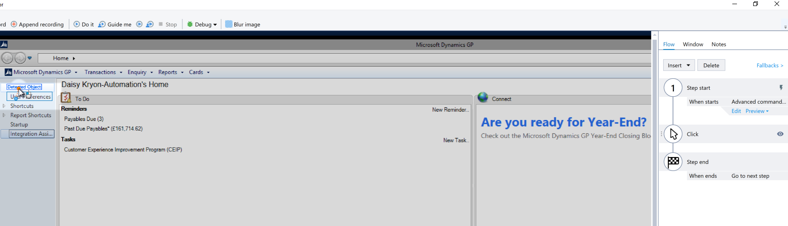

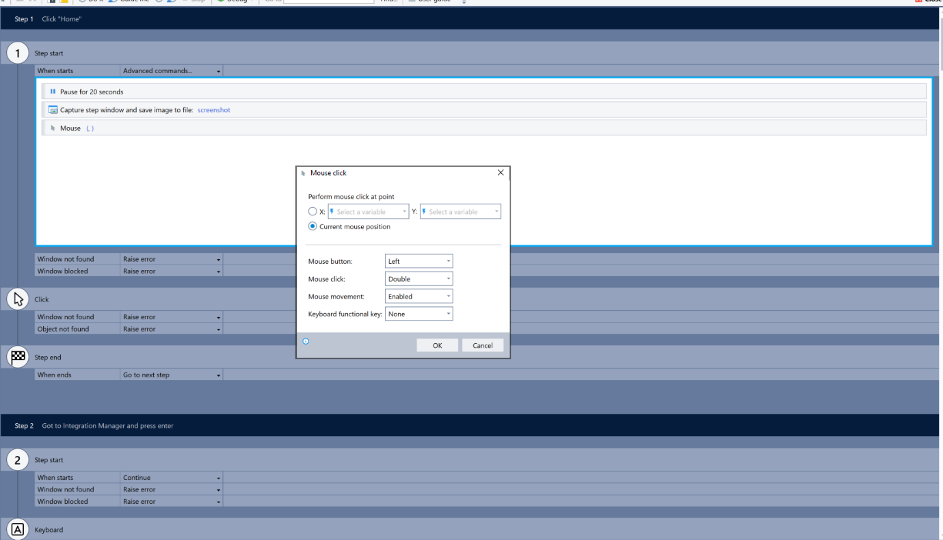
Fig 14. Adding extra double click at mouse position to activate the window

This fix did not provide the reliability required. Great plains would sometimes become ‘active’ but not enough for the wizard to comfortably run un-monitored, which is a requirement.
I attempted a different approach, instead of using a mouse click I implemented use of keyboard shortcuts to navigate to the integration assistant and press enter (fig 15).

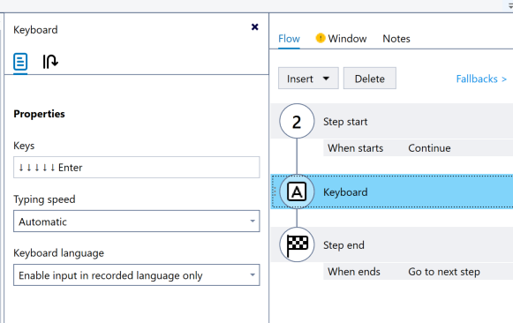
Fig 15. Addition of keyboard use

This provided an increased success rate, but the window would still fail to become active 3/5 times we ran it. At this point myself and Joe had each time numerous attempts to fix. In stand-up, I updated on these difficulties and Ed suggested contacting Kryon support with the issue.

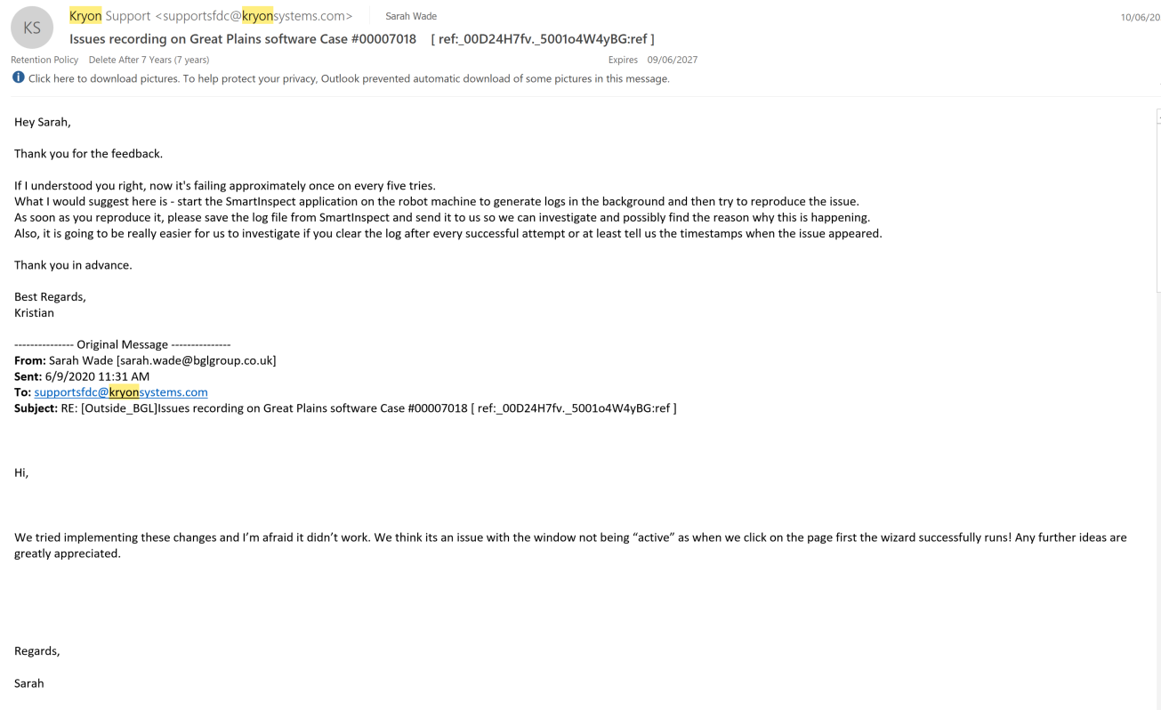
I contacted Kryon support via email and explained what was happening and what I had used to attempt to resolve it so far. With an open dialogue, I implemented the changes Kryon suggested worked closely with them over email (fig 16).
Fig 16. Working with Kryon support

The email support continued over the course of a week. In the meantime, I continued to try and implement a more stable fix. After a lot of experimentation, and investigation into Kryon commands I thought about how usually you can make a window active, and came up with the idea of minimising the window then opening it again to bring it to the front. I implemented this and the success rate increased dramatically, out of ten tries the wizard failed only once, and this was due to particularly bad performance of the test server on that occasion.

I was reasonably confident at this point of the stability of the PL process. I created a test plan (see fig 17 below) which included all previously known errors encountered, and other possible errors that are known to Kryon. I also included tests that ensured the requirements of the original problem statement were being met. I then organised a QA review, which is required to get QA sign off in our company. Our ticket received sign off from the Quality engineer.
Fig 17. Test Plan to BGL standards
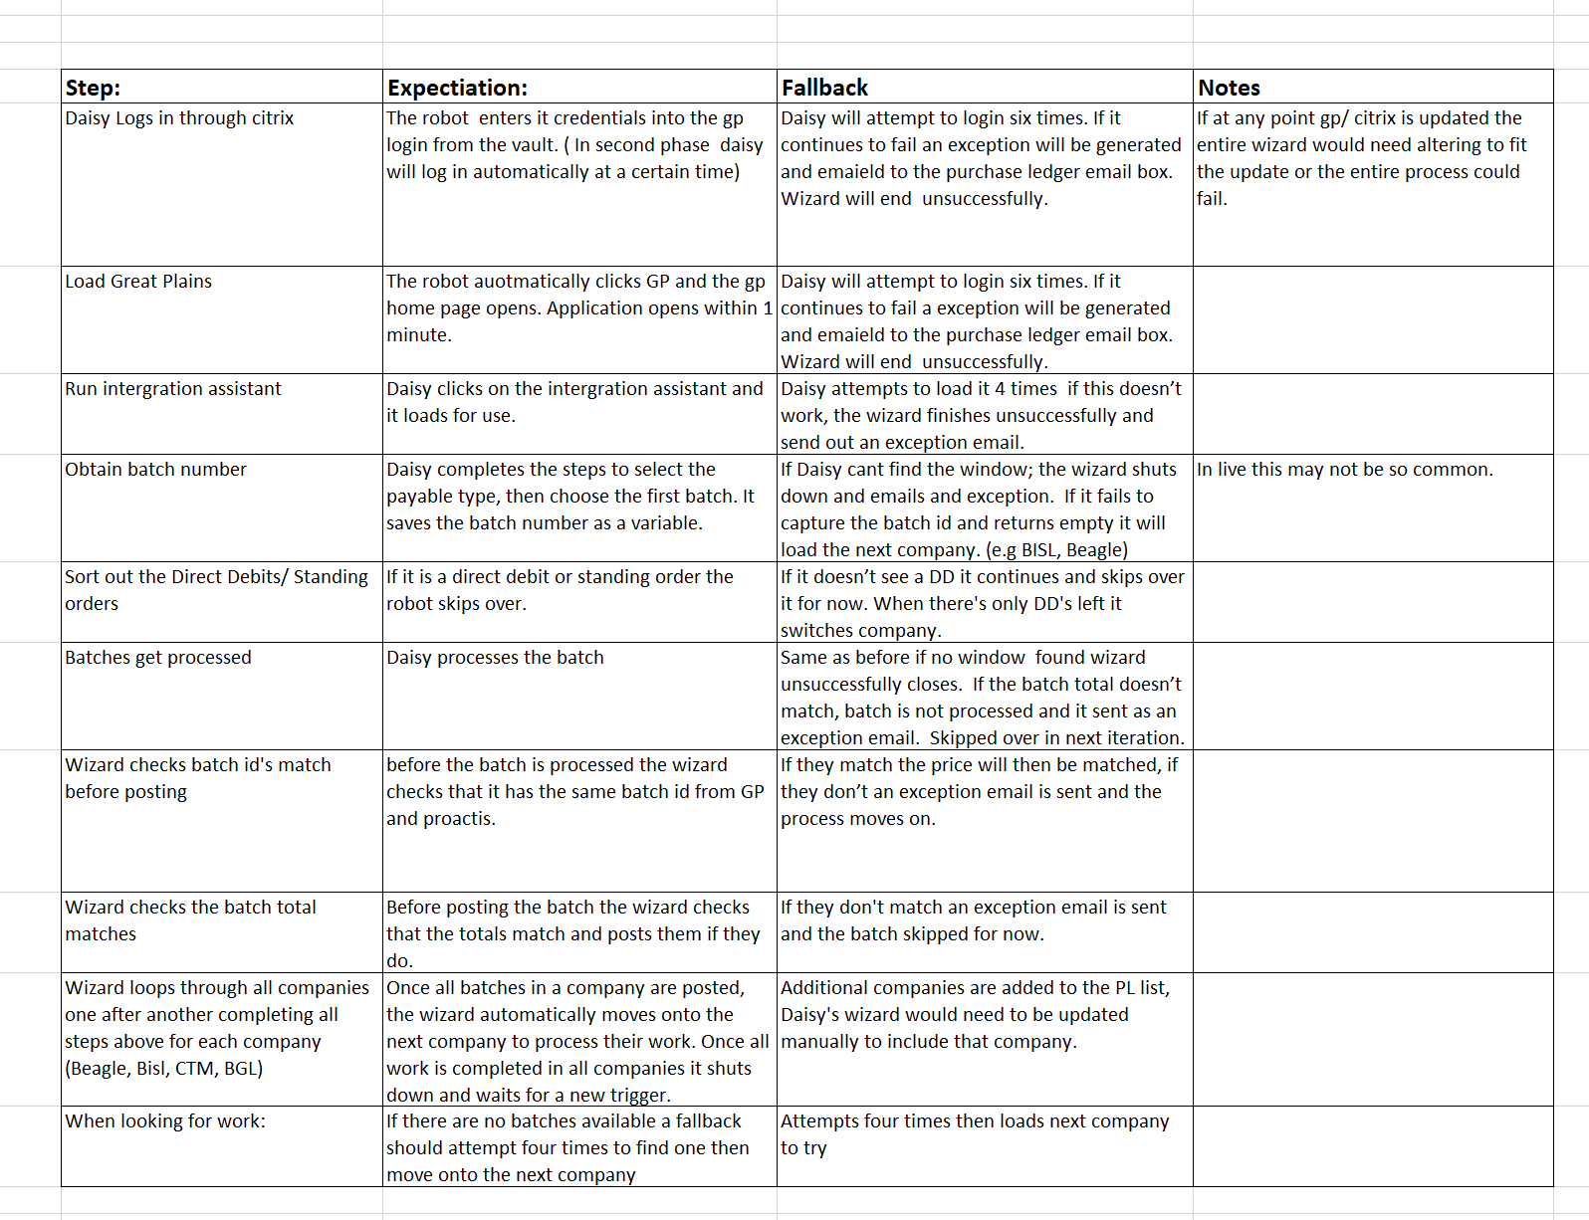
The next action was to have a code review with a senior member of the RPA team, Ed. Ed asked for a demo of the process then a clear walkthrough of the logic and structure. I answered questions about the fall-back, safety mechanisms and password security of our program. Ed was satisfied with the work completed but voiced concern with the overall performance of the program. He suggested the slow response time we had been experiencing with GP was because of the test server it was currently deployed in. Ed proposed taking our process into live testing.
A lot of work towards the main ticket was completed during this stage. I also found and resolved a lot of the main bugs in the process that would have affected the reliability of the process in live. I managed to find a solution to the integration manager which enabled the process to continue to live monitoring. I was not entirely satisfied with this resolution as it seemed somewhat messy, minimising and then maximising the browser adds quite a few seconds to an already relatively long process. After my call with Kryon support I felt more satisfied when the agent could not find another way to improve it and said that was the most stable fix available at the moment.
I worked more autonomously during this stage, and felt comfortable to do so once I was more confident of the process. I also worked effectively with my team sought help on issues that were holding the process up. Ideally the integration manager issue would not have delayed the demo by so long, I could possibly have raised the issue sooner to prevent this.

The end demo to the product owners went very well and they were happy to sign off ready for live testing, as Ed suggested.

Live Deployment Stage

The final stage of this project was to deploy the process into a live environment and monitor it.
In the RPA deploying a program to the live environment involved several steps. These steps were:
- Altering the wizard to point from the test environment to the live environment
- Ensuing the robot had correct permissions to access the live environment
- Migrating the wizard over to the virtual machine for the robot to access
- Holding sessions with Ollie for handover upon deployment
- Setting up triggers to enable the program to run automatically

I began by making the necessary changes to the program to ensure it loaded the live environment instead of the testing on. This involved changing the script that ran the start-up program to point to a live endpoint rather than the testing one.

Next I moved the process onto the virtual machine where Daisy robot was setup by simply exporting the wizard into a ‘.jwiz’ file and saving it locally on the virtual machine. I worked alongside Ed and Joe to complete this action to ensure it was placed in the correct location. Once it was moved onto the virtual machine(vm) the next stage was again manually running the process through to test it still worked as expected.
Once satisfied that the program was running correctly I contacted Ollie and gave him a thorough walkthrough of the process and trained him how to troubleshoot problems and turn the robot on and off. I also updated the jira ticket with the progress made.
Once Ollie was comfortable with the Wizard and was happy to handover I went into the Kryon admin and began the final step required for going into live. This was setting up the triggers that would activate the robot to automatously run the program. I used a Crohn expression to initiate the triggers(fig 18).
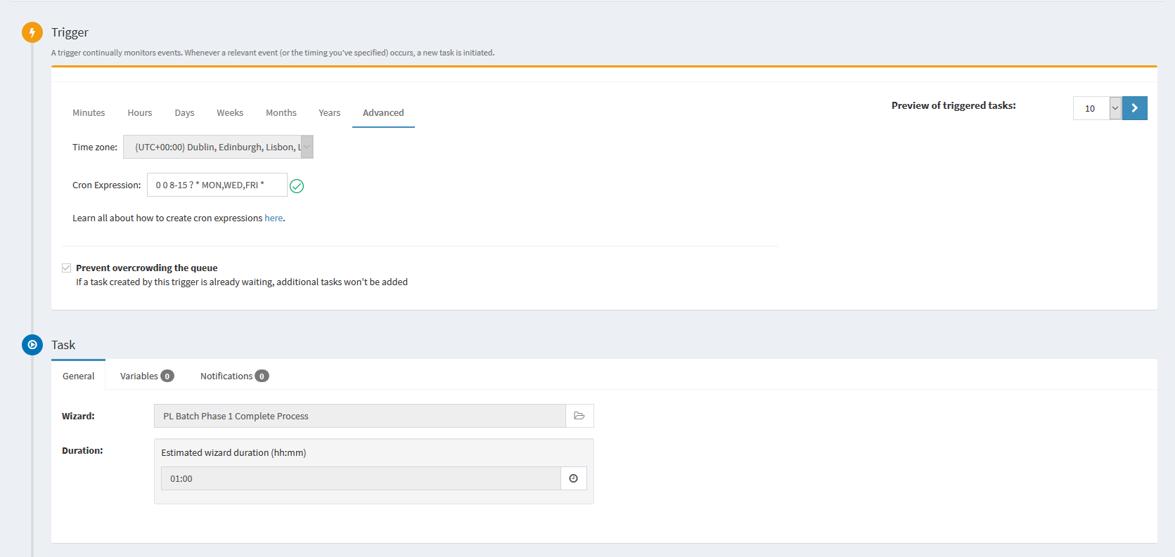
Fig 18 Trigger Setup

Once the process was setup and the trigger points activated the process was ready to go live and be handed over to Ollie. I remained in contact with Ollie throughout the live monitoring phase and offered my support whenever a problem arose. I assisted with one post-live change which Ollie needed support with which was to add advance commands to read different data from the screen than the process currently covered. I also kept in contact with purchase ledger team through a Microsoft teams channel, which they will post questions and problems in there for assistance and updates.

Conclusion

The overall deliverable of this piece of work was a concise wizard that ran automatically on the robot ‘Daisy’. This wizard met the requirements of the initial ticket. It took batches that had matching invoice payments with no errors and processed them, which would save the purchase ledger team hours of work each week. I moved project at the point of live monitoring but kept in contact with Ollie and had several calls to support him when the wizard did not behave as expected. This completely meets with RPA team agenda, and the product owners were extremely satisfied with the work completed.
In the live demo session, I received feedback from several of the product owners which was invaluable. One comment was that the wizard took a while to run through due to the many extra waiting times that had been programmed into the wizard. I explained that this was to ensure reliability of the program and could possibly be reduced now that the program is in live monitoring.

One of the main ideals for an RPA process was that it had to be very reliable, at times it was challenging to get the process to meet the criteria, and a lot of development time was spent trying to ensure the reliability and stability of each stage. This did cause a delay in deploying the process to live monitoring but I am happy with my decision to delay as it meant what was delivered met the users needs far more adequately. I could have asked for help sooner with some of the problems which might have enabled the process to go into live monitoring days sooner and this is something I will keep in mind for my next project.

I feel that I developed my interpersonal skills a lot during this ticket. At the beginning, I was sometimes reluctant to contact people I didn’t know about problems I was experiencing. For example, with the SME if I’d included him earlier I could have gained a lot more knowledge on the process faster and avoided some deliberating over the best approach to record the process. By the end of development, I felt completely comfortable collaborating with stakeholder’s Ba’s and other developers, and even took it upon myself to personally update RPA’s senior manager when I was experiencing issues. This is something that would have been daunting at the beginning of the process but was second nature by the end. If I were to complete a similar piece of work using the same technology, I am confident I would be able to deliver it with much less guidance and far more autonomy from the start.

